
SESSION: 2025-26

MINI PROJECT REPORT
On
“Book Exchange Platform”

BACHELOR OF TECHNOLOGY IN COMPUTER
SCIENCE AND ENGINEERING
Submitted to-
(Mr. Navneet Gupta )
(Department of Computer Science & Engineering)
Submitted by-
Kartik Sharma (2300680100148)
Himanshu Kumar (2300680100134)
Kapish Shanker (2300680100145)

5th SEMESTER
DEPARTMENT OF COMPUTER
SCIENCE AND ENGINEERING
MEERUT INSTITUTE OF ENGINEERING AND TECHNOLOGY, MEERUT

DECLARATION

We hereby declare that the project entitled -“ Book Exchange Platform”, which is being submitted as Mini Project in department of Computer Science and engineering to Meerut Institute of Engineering and Technology, Meerut (U.P.) is an authentic record of our genuine work done under the guidance of Prof. “Mr. Navneet Gupta” of Computer Science and Engineering, Meerut Institute of Engineering and Technology, Meerut.

Date: 03/12/2025
Kartik Sharma (2300680100148)
Himanshu Kumar (2300680100134)
Kapish Shanker (2300680100145)

CERTIFICATE

This is to certify that Mini Project report titled – “Book Exchange Platform” submitted by Kartik Sharma (2300680100148), Himanshu Kumar (2300680100134), Kapish Shanker (2300680100145) has been carried out under the guidance of Assistant Professor Mr. Navneet Gupta Sir of "Computer Science & Engineering (CSE)", Meerut Institute of Engineering and Technology (MIET), Meerut. This project report is approved for Project/Mini Project in 5th Semester in CSE from Meerut Institute of Engineering and Technology, Meerut.

Supervisor Sign:
Supervisor Name: Mr. Navneet Gupta
Date: 03/12/2025
.

ACKNOWLEDGEMENT

I express my sincere indebtedness towards our guide Prof., “Mr. Navneet Gupta” of Computer Science and Engineering, Meerut Institute of Engineering and Technology, Meerut for his valuable suggestion, guidance and supervision throughout the work. Without his king patronage and guidance the project would not have taken shape. I would also like to express my gratitude and sincere regards for his kind approval of the project. Time to time counseling and advises.
I would also like to thank to our HoD Dr. (Prof.) “Vikas Shrivastava”, Department of Computer Science and engineering, Meerut Institute of Engineering and Technology, Meerut for his expert advice and counseling from time to time.
I owe sincere thanks to all the faculty members in the department of Computer Science and engineering for their kind guidance and encouragement time to time.

Date: 03/12/2024

Kartik Sharma (2300680100148)
Himanshu Kumar (2300680100134)
Kapish Shanker (2300680100145)

Table of contents
Description page no.
Declaration i
Certificate ii
Acknowledgement iii

Chapter 1 Introduction
Chapter 2 System Design
(Work flow/flow chart/DFD/ working principle/ constructional details of individual componenets)
Chapter 3 Technology Bucket
3.1 Description of HTML
3.2 Description of CSS
3.3 Description of Java Script
3.4 Description of Python
3.5 Description of Mysql
Chapter 4 Output screens
Appendices Implementation code
References

CHAPTER : 1
Book Exchange Platform – Project Introduction

The Book Exchange Platform is a user-friendly web application designed to simplify the process of sharing, renting, and buying books within a community. The platform connects readers who wish to exchange their books with others, helping reduce costs while promoting sustainable reading habits. Users can create an account, upload books by providing details such as title, author, description, and pricing for both rent and purchase. Images of books can also be uploaded to improve listing clarity.

Once uploaded, books are displayed in a clean and interactive interface where others can browse available listings. Each book card shows essential details along with options to rent or buy. Clicking these options reveals the book owner's contact details, including name, mobile number, and system-generated address information, ensuring smooth communication.

On the backend, MySQL is used to securely store book and user information, while the frontend relies on HTML, CSS, and JavaScript for an engaging user experience. The platform is built with scalability in mind, making it suitable for college campuses, local reading groups, or public communities.

This project ultimately aims to encourage reading, reduce book wastage, and foster a collaborative sharing culture.

FEATURES :
1. User-friendly Book Upload System
- Users can upload books with details like title, author,
description,rent price, buy price, and book image.
- Information is securely stored in MySQL.
2. Dynamic Book Listing
- All uploaded books are displayed in a clean grid layout.
- Each book card shows:
- Book image
- Title
- Author
- Description
- Rent & Buy options with prices
3. Rent & Buy Functionality
- Clicking Rent or Buy opens a modal showing:
- Owner’s name
- Mobile number (from MySQL)
- System-generated address & pincode
- Selected price
4. Responsive UI
- Built using HTML, CSS, and JavaScript.
- Works smoothly on different screen sizes.
5. Automatic Address Generator
- Each book listing is assigned a random address and pincode for demo purposes.
6. Backend Integration
- Secure data storage using MySQL database.
- Backend API handles fetching uploaded books.
7. Scalable & Community-Oriented
- Suitable for colleges, hostels, book clubs, and community groups.
- Promotes book sharing and reduces waste.

CHAPTER :2
SYSTEM DESIGN
FLOW CHART:

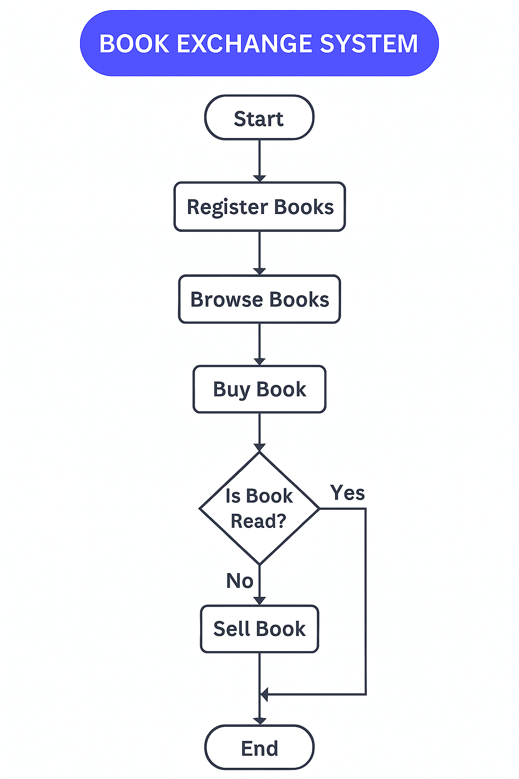
Architecture Overview:

Presentation Layer:
This layer represents the user interface, developed using HTML, CSS, and JavaScript. It is responsible for displaying weather data, user inputs, and interactive elements. Responsive design principles ensure compatibility across devices like smartphones, tablets, and desktops.

Application Layer:
This layer handles the app’s functionality, ensuring dynamic updates and real-time interactions. JavaScript plays a critical role here, managing features like data retrieval, processing, and user-triggered actions.

Data Layer:
This layer retrieves weather data from external APIs and organizes it for user-friendly presentation. JavaScript fetches and processes the data, ensuring accuracy and relevance.

System Features :

Real-Time Updates:
HTML structures the content, CSS styles the presentation, and JavaScript ensures realtime updates.

Dynamic Backgrounds:
CSS and JavaScript work together to implement interactive visuals based on current weather conditions.

Responsive Design:
HTML and CSS ensure seamless adaptability across different devices and screen sizes.

CHAPTER :3
Technologies Used

1. HTML (HyperText Markup Language)
HTML is used to create the structure of all web pages in the platform. It defines the layout of elements such as forms, buttons, book cards, images, and navigation menus. HTML ensures that content is properly organized and displayed in the browser.
2. CSS (Cascading Style Sheets)
CSS is used to design the appearance and styling of the platform. It handles fonts, colors, spacing, animations, layouts, and responsive design. CSS makes the book exchange platform look clean, attractive, and user-friendly.
3. JavaScript
JavaScript adds interactivity to the website. It is used for:
- Form validations
- Dynamic book card loading
- Handling button clicks
- Updating content without refreshing the page
- Improving overall user experience

4. Python
Python is used as the backend language to handle the server-side logic of the project. It manages:
- Storing user details
- Uploading book data
- Processing requests
- Communicating with the MySQL database
- Backend APIs for adding, updating, and retrieving book information
Python frameworks (like Flask/Django) can be used to build routes and APIs for the platform.
5. MySQL
MySQL serves as the database of the project. It stores:
- User information
- Book details
- Book images (paths)
- Rent price, buy price
- Upload history
- Transactions or exchange records

CHAPTER : 4
OUTPUT SCREEN
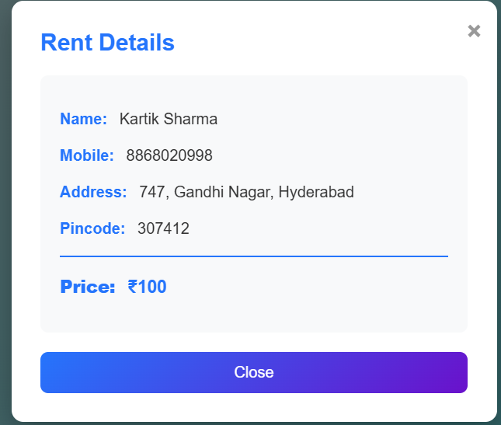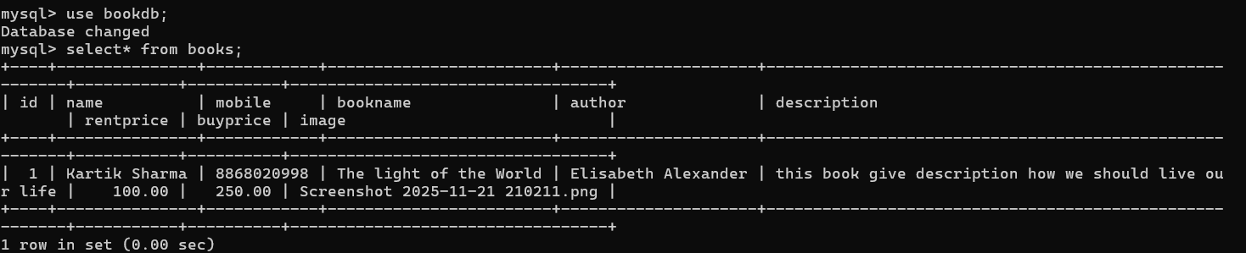
CODE IMPLEMENTATION:
HTML:
1. Index.html
<!DOCTYPE html>
<html lang="en">
<head>
<meta charset="UTF-8">
<meta name="viewport" content="width=device-width, initial-scale=1.0">
<title>Book Collection</title>
<link rel="stylesheet" href="/static/style.css">
</head>
<body>
<!-- Login Page -->
<div id="loginPage">
<form id="loginForm">
<h2>Login</h2>
<input type="text" id="username" placeholder="Username" required>
<input type="password" id="password" placeholder="Password" required>
<button type="submit">Login</button>
<p id="errorMsg"></p>
</form>
</div>
<!-- Main Page -->
<div id="mainContent">
<div class="navbar">
<form id="searchForm">
<button type="button" onclick="window.location.href='/'">Home</button>

<!-- UPLOADED BOOKS BUTTON -->
<button type="button" onclick="window.location.href='/uploaded_books'">Uploaded Books</button>

<button type="button" onclick="window.location.href='/upload_page'">Upload</button>

<input type="text" id="searchInput" placeholder="Search book...">
<button type="submit">Search</button>
</form>
<button class="login-btn" onclick="logout()">Logout</button>
</div>

<h1>Book Exchange Platform</h1>

<div id="bookGrid"></div>
</div>

<script src="/static/script.js"></script>
</body>
</html>

2. Upload.html
<!DOCTYPE html>
<html lang="en">
<head>
<meta charset="UTF-8">
<meta name="viewport" content="width=device-width, initial-scale=1.0">
<title>Upload Book</title>
<link rel="stylesheet" href="/static/style.css">
</head>
<body>
<div class="navbar">
<button onclick="window.location.href='/'">Home</button>
<button onclick="window.location.href='/uploaded_books'">Uploaded Books</button>
<button class="active">Upload</button>
</div>

<div class="upload-container">
<h1>📖 Upload Your Book</h1>
<form action="/upload" method="POST" enctype="multipart/form-data" class="upload-form">
<div class="form-group">
<label for="name">Your Name:</label>
<input type="text" id="name" name="name" required>
</div>

<div class="form-group">
<label for="mobile">Mobile Number:</label>
<input type="tel" id="mobile" name="mobile" required>
</div>

<div class="form-group">
<label for="bookname">Book Name:</label>
<input type="text" id="bookname" name="bookname" required>
</div>

<div class="form-group">
<label for="author">Author:</label>
<input type="text" id="author" name="author" required>
</div>

<div class="form-group">
<label for="description">Description:</label>
<textarea id="description" name="description" rows="4" required></textarea>
</div>

<div class="form-group">
<label for="rentprice">Rent Price (₹):</label>
<input type="number" id="rentprice" name="rentprice" step="0.01" required>
</div>

<div class="form-group">
<label for="buyprice">Buy Price (₹):</label>
<input type="number" id="buyprice" name="buyprice" step="0.01" required>
</div>

<div class="form-group">
<label for="image">Book Cover Image:</label>
<input type="file" id="image" name="image" accept="image/*" required>
</div>

<button type="submit" class="submit-btn">Upload Book</button>
</form>
</div>
</body>
</html>

3. Uploaded.html
<!DOCTYPE html>
<html>
<head>
<meta charset="UTF-8">
<meta name="viewport" content="width=device-width, initial-scale=1.0">
<title>Uploaded Books</title>
<link rel="stylesheet" href="/static/style.css">
</head>
<body>

<div class="navbar">
<button onclick="window.location.href='/'">Home</button>
<button class="active">Uploaded Books</button>
<button onclick="window.location.href='/upload_page'">Upload</button>
</div>

<h1 style="text-align:center; color:white; margin: 20px 0;">📚 Uploaded Books</h1>

<div id="uploadedGrid" class="book-grid"></div>

<script src="/static/uploaded.js"></script>

</body>
</html>

CSS:
@import url('https://fonts.googleapis.com/css2?family=PT+Sans:wght@400;700&display=swap');
*{margin:0;padding:0;box-sizing:border-box;}
body{font-family:'Poppins',sans-serif;margin:0;background:linear-gradient(135deg,#fefdff,#3cedf7);color:#333;min-height:100vh;}
h1{font-family:'Poppins',sans-serif;font-size:2rem;font-weight:600;text-align:center;margin:30px 0;background:linear-gradient(90deg,#f351d5,#f840d0);-webkit-background-clip:text;-webkit-text-fill-color:transparent;letter-spacing:1px;text-transform:capitalize;}
@keyframes glow{from{text-shadow:0 0 10px #ff6a00,0 0 20px #ee0979,0 0 30px #ff6a00;}to{text-shadow:0 0 20px #ee0979,0 0 40px #ff6a00,0 0 60px #ee0979;}}
#loginPage{display:flex;justify-content:center;align-items:center;height:100vh;animation:fadeIn 1s ease-in-out;}
#loginForm{background:white;padding:40px;border-radius:12px;box-shadow:0 10px 25px rgba(0,0,0,0.25);text-align:center;width:320px;transition:transform .3s ease,box-shadow .3s ease;}
#loginForm:hover{transform:translateY(-5px);box-shadow:0 15px 30px rgba(0,0,0,0.3);}
#loginForm input{width:100%;padding:12px;margin:10px 0;border:1px solid #ccc;border-radius:8px;transition:.3s;}
#loginForm input:focus{border-color:#6a11cb;outline:none;box-shadow:0 0 8px rgba(106,17,203,.4);}
#loginForm button{width:100%;padding:12px;background:linear-gradient(135deg,#2575fc,#6a11cb);color:white;border:none;border-radius:8px;cursor:pointer;font-size:16px;font-weight:500;transition:transform .2s ease,box-shadow .3s ease;}
#loginForm button:hover{transform:translateY(-2px);box-shadow:0 6px 15px rgba(0,0,0,.2);}
#errorMsg{color:red;font-size:14px;margin-top:10px;}
.navbar{display:flex;justify-content:space-between;align-items:center;background:linear-gradient(135deg,#93b874,#7aa364);padding:12px 20px;box-shadow:0 4px 10px rgba(0,0,0,.3);}
.navbar form{display:flex;align-items:center;gap:12px;}
.navbar button{background:linear-gradient(135deg,#93b874,#7aa364);color:black;border:none;padding:8px 15px;border-radius:6px;cursor:pointer;transition:.3s;font-size:18px;}
.navbar button:hover{background:linear-gradient(135deg,#5efc25,#0e0715);transform:scale(1.05);}
.navbar input{padding:8px;border-radius:6px;border:1px solid #ccc;transition:.3s;}
.navbar input:focus{border-color:#2575fc;outline:none;box-shadow:0 0 6px rgba(37,117,252,.4);}
.login-btn{background:linear-gradient(135deg,#ff4757,#e84118);}
.login-btn:hover{background:linear-gradient(135deg,#ff6b81,#ff4757);}
#bookGrid,.book-grid{display:grid;grid-template-columns:repeat(5,1fr);gap:25px;padding:30px;}
.book-card{background:#fff;border-radius:12px;box-shadow:0 6px 15px rgba(0,0,0,.15);padding:20px;text-align:center;transition:transform .3s ease,box-shadow .3s ease;border:2px solid transparent;width:100%;max-width:280px;margin:0 auto;}
.book-card img{max-width:100%;height:220px;object-fit:cover;border-radius:8px;margin-bottom:12px;transition:transform .3s ease;}
.book-card:hover img{transform:scale(1.05);}
.book-card h3{font-size:18px;margin:8px 0;color:#2575fc;}
.book-card p{font-size:14px;color:#555;min-height:40px;}
.book-card .btn-group{margin-top:12px;display:flex;justify-content:center;gap:12px;}
.book-card button{padding:8px 14px;border:none;border-radius:6px;cursor:pointer;color:white;font-size:14px;transition:.3s;}
.book-card .rent{background:linear-gradient(135deg,#28a745,#218838);}
.book-card .buy{background:linear-gradient(135deg,#007bff,#0056b3);}
.book-card .rent:hover{background:linear-gradient(135deg,#34d058,#28a745);transform:scale(1.05);}
.book-card .buy:hover{background:linear-gradient(135deg,#3399ff,#007bff);transform:scale(1.05);}
.upload-container{max-width:600px;margin:40px auto;background:white;padding:30px;border-radius:12px;box-shadow:0 10px 25px rgba(0,0,0,.25);animation:fadeIn 1s ease-in-out;}
.upload-container h1{color:#2575fc;margin-bottom:30px;}
.upload-form{display:flex;flex-direction:column;gap:20px;}
.form-group{display:flex;flex-direction:column;}
.form-group label{font-weight:bold;margin-bottom:5px;color:#333;}
.form-group input,.form-group textarea{padding:10px;border:1px solid #ccc;border-radius:8px;font-size:14px;font-family:'Poppins',sans-serif;transition:.3s;}
.form-group input:focus,.form-group textarea:focus{outline:none;border-color:#2575fc;box-shadow:0 0 8px rgba(37,117,252,.4);}
.submit-btn{padding:12px 20px;background:linear-gradient(135deg,#2575fc,#6a11cb);color:white;border:none;border-radius:8px;font-size:16px;cursor:pointer;transition:transform .2s ease,box-shadow .3s ease;}
.submit-btn:hover{transform:translateY(-2px);box-shadow:0 6px 15px rgba(0,0,0,.2);}
@keyframes fadeIn{from{opacity:0;transform:translateY(20px);}to{opacity:1;transform:translateY(0);}}
@media(max-width:1200px){#bookGrid,.book-grid{grid-template-columns:repeat(3,1fr);}}
@media(max-width:768px){#bookGrid,.book-grid{grid-template-columns:repeat(2,1fr);} .navbar form{flex-wrap:wrap;}}
@media(max-width:480px){#bookGrid,.book-grid{grid-template-columns:1fr;}}
.person-modal{display:flex;position:fixed;z-index:1000;left:0;top:0;width:100%;height:100%;background-color:rgba(0,0,0,.6);animation:fadeIn .3s ease-in-out;justify-content:center;align-items:center;}
.person-modal-content{background:white;padding:30px;border-radius:12px;box-shadow:0 10px 30px rgba(0,0,0,.3);max-width:500px;width:90%;position:relative;animation:slideDown .3s ease-in-out;}
@keyframes slideDown{from{opacity:0;transform:translateY(-50px);}to{opacity:1;transform:translateY(0);}}
.person-modal-close{position:absolute;right:15px;top:15px;font-size:28px;font-weight:bold;color:#999;cursor:pointer;transition:color .3s;}
.person-modal-close:hover{color:#333;}
.person-modal-content h2{color:#2575fc;margin-bottom:20px;font-size:24px;}
.person-details{background:#f8f9fa;padding:20px;border-radius:8px;margin-bottom:20px;}
.person-details p{margin:12px 0;font-size:16px;color:#333;line-height:1.6;}
.person-details strong{color:#2575fc;margin-right:8px;}
.person-details .price-info{margin-top:15px;padding-top:15px;border-top:2px solid #2575fc;font-size:18px;color:#2575fc;font-weight:bold;}
.close-modal-btn{width:100%;padding:12px;background:linear-gradient(135deg,#2575fc,#6a11cb);color:white;border:none;border-radius:8px;font-size:16px;cursor:pointer;transition:transform .2s ease,box-shadow .3s ease;font-weight:500;}
.close-modal-btn:hover{transform:translateY(-2px);box-shadow:0 6px 15px rgba(0,0,0,.2);}
.container-glass,.container-glass::before,.container-glass::after{border-radius:7px;background-color:rgba(255,255,255,.2);backdrop-filter:blur(5px);box-shadow:0px 0px 22px rgba(0,0,0,.08);}
.container-glass{position:relative;padding:2rem 1.5rem;width:80%;max-width:280px;}
.container-glass::before,.container-glass::after{content:'';position:absolute;}
.container-glass::before{height:80px;width:80px;top:-10px;left:-40px;z-index:-1;}
.container-glass::after{height:40px;width:40px;bottom:20px;right:-10px;z-index:2;}
.container-glass .img{width:100%;border-radius:7px;}
.container-glass .text{font-size:1.01rem;color:#DDD;margin:2rem 0;text-align:justify;}
.container-glass .btn{display:block;margin:auto;font-family:'PT Sans',sans-serif;font-size:1.02rem;width:80%;max-width:200px;padding:.6rem 1rem;background-color:transparent;border:1px solid #ffdd00;border-radius:5px;color:#ffdd00;cursor:pointer;transition:.2s;}
.container-glass .btn:hover{background-color:#ffdd00;color:#333;}

JAVA SCRIPT:
1. script.js
// Login credentials
const validUsername="admin",validPassword="12345";

// Auto-login check
window.addEventListener("DOMContentLoaded",()=>{
if(localStorage.getItem("isLoggedIn")==="true"){
loginPage.style.display="none";
mainContent.style.display="block";
loadRandomBooks();
}
});

// Login
loginForm?.addEventListener("submit",e=>{
e.preventDefault();
const u=username.value,p=password.value;
if(u===validUsername && p===validPassword){
localStorage.setItem("isLoggedIn","true");
loginPage.style.display="none";
mainContent.style.display="block";
loadRandomBooks();
} else errorMsg.textContent="Invalid username or password!";
});

// Logout
function logout(){
localStorage.removeItem("isLoggedIn");
mainContent.style.display="none";
loginPage.style.display="flex";
username.value=password.value=errorMsg.textContent="";
}

// Wikipedia description
async function fetchWikipediaDescription(t,a){
try{
const url=`https://en.wikipedia.org/api/rest_v1/page/summary/${encodeURIComponent(t.replace(/[()]/g,"").trim())}`;
const r=await fetch(url); if(!r.ok) return null;
const d=await r.json();
return d.extract && d.extract.length>50 && !d.type ? d.extract.slice(0,150)+"..." : null;
}catch{return null;}
}

// Fallback description
function generateFallbackDescription(b){
const t=b.title||"This book",a=b.author_name?b.author_name[0]:"an author",
y=b.first_publish_year,s=b.subject?.[0];
return `${t} by ${a}${y?`, published in ${y}`:""}. ${s?`${s.toLowerCase()} novel`:"An engaging literary work"}`;
}

// Random prices
function generatePrices(){
const rent=50+Math.floor(Math.random()*16)*10;
const buyMin=Math.max(200,rent),buy=buyMin+Math.floor(Math.random()*((350-buyMin)/10+1))*10;
return {rentPrice:rent,buyPrice:buy};
}

// Random person details
function generateRandomPersonDetails(){
const fn=["Raj","Priya","Amit","Sneha","Vikram","Anjali","Rahul","Kavita","Suresh","Meera","Arjun","Divya","Karan","Pooja","Rohan","Neha"],
ln=["Sharma","Patel","Kumar","Singh","Gupta","Verma","Yadav","Reddy","Joshi","Malhotra","Agarwal","Mehta","Shah","Desai","Nair","Rao"],
st=["MG Road","Park Street","Main Street","Gandhi Nagar","Nehru Colony","Indira Nagar","Rajiv Nagar","Vijay Nagar","Shanti Nagar","Prem Nagar"],
ct=["Mumbai","Delhi","Bangalore","Hyderabad","Chennai","Kolkata","Pune","Ahmedabad","Jaipur","Lucknow"];
return {
name:`${fn[Math.random()*fn.length|0]} ${ln[Math.random()*ln.length|0]}`,
mobile:`9${Math.floor(Math.random()*9)+1}${Math.floor(Math.random()*90000000)+10000000}`,
address:`${Math.floor(Math.random()*999)+1}, ${st[Math.random()*st.length|0]}, ${ct[Math.random()*ct.length|0]}`,
pincode:Math.floor(Math.random()*900000)+100000
};
}

// Modal
function showPersonDetailsModal(p,action,price){
document.getElementById("personDetailsModal")?.remove();
const m=document.createElement("div");
m.id="personDetailsModal"; m.className="person-modal";
m.innerHTML=`
<div class="person-modal-content">
<span class="person-modal-close">&times;</span>
<h2>${action} Details</h2>
<div class="person-details">
<p><strong>Name:</strong> ${p.name}</p>
<p><strong>Mobile:</strong> ${p.mobile}</p>
<p><strong>Address:</strong> ${p.address}</p>
<p><strong>Pincode:</strong> ${p.pincode}</p>
<p class="price-info"><strong>Price:</strong> ₹${price}</p>
</div>
<button class="close-modal-btn">Close</button>
</div>`;
document.body.appendChild(m);
m.querySelector(".person-modal-close").onclick=
m.querySelector(".close-modal-btn").onclick=()=>m.remove();
m.onclick=e=>{ if(e.target===m) m.remove(); };
}

// Load random books
async function loadRandomBooks(){
bookGrid.innerHTML="Loading books...";
try{
const r=await fetch("https://openlibrary.org/search.json?q=fiction&limit=100");
const d=await r.json(); bookGrid.innerHTML="";
const books=d.docs.sort(()=>0.5-Math.random()).slice(0,25);

for(const b of books){
const title=b.title||"No title",author=b.author_name?.join(", ")||"Unknown",
cover=b.cover_i?`https://covers.openlibrary.org/b/id/${b.cover_i}-M.jpg`:"https://via.placeholder.com/150x200?text=No+Cover",
desc=await fetchWikipediaDescription(title,author)||generateFallbackDescription(b),
{rentPrice,buyPrice}=generatePrices(),
p=generateRandomPersonDetails();

const c=document.createElement("div");
c.className="book-card";
c.innerHTML=`
<img src="${cover}">
<h3>${title}</h3>
<p><strong>${author}</strong></p>
<p>${desc}</p>
<div class="btn-group">
<button class="rent">Rent ₹${rentPrice}</button>
<button class="buy">Buy ₹${buyPrice}</button>
</div>`;
c.dataset.personName=p.name;
c.dataset.personMobile=p.mobile;
c.dataset.personAddress=p.address;
c.dataset.personPincode=p.pincode;

c.querySelector(".rent").onclick=()=>showPersonDetailsModal(p,"Rent",rentPrice);
c.querySelector(".buy").onclick=()=>showPersonDetailsModal(p,"Buy",buyPrice);

bookGrid.appendChild(c);
}
}catch{
bookGrid.innerHTML="Error loading books.";
}
}

// Search
searchForm?.addEventListener("submit",async e=>{
e.preventDefault();
const q=searchInput.value; bookGrid.innerHTML="Searching...";
try{
const r=await fetch(`https://openlibrary.org/search.json?title=${encodeURIComponent(q)}&limit=25`);
const d=await r.json(); bookGrid.innerHTML="";
if(!d.docs.length) return bookGrid.innerHTML="No books found.";

for(const b of d.docs.slice(0,25)){
const title=b.title||"No title",author=b.author_name?.join(", ")||"Unknown",
cover=b.cover_i?`https://covers.openlibrary.org/b/id/${b.cover_i}-M.jpg`:"https://via.placeholder.com/150x200?text=No+Cover",
desc=await fetchWikipediaDescription(title,author)||generateFallbackDescription(b),
{rentPrice,buyPrice}=generatePrices(),
p=generateRandomPersonDetails();

const c=document.createElement("div");
c.className="book-card";
c.innerHTML=`
<img src="${cover}">
<h3>${title}</h3>
<p><strong>${author}</strong></p>
<p>${desc}</p>
<div class="btn-group">
<button class="rent">Rent ₹${rentPrice}</button>
<button class="buy">Buy ₹${buyPrice}</button>
</div>`;

c.dataset.personName=p.name;
c.dataset.personMobile=p.mobile;
c.dataset.personAddress=p.address;
c.dataset.personPincode=p.pincode;

c.querySelector(".rent").onclick=()=>showPersonDetailsModal(p,"Rent",rentPrice);
c.querySelector(".buy").onclick=()=>showPersonDetailsModal(p,"Buy",buyPrice);

bookGrid.appendChild(c);
}
}catch{
bookGrid.innerHTML="Error fetching data.";
}
});

2. Uploded.js
// Generate random address and pincode (name and mobile come from MySQL)
function generateAddressAndPincode() {
const streets = ["MG Road", "Park Street", "Main Street", "Gandhi Nagar", "Nehru Colony", "Indira Nagar", "Rajiv Nagar", "Vijay Nagar", "Shanti Nagar", "Prem Nagar"];
const cities = ["Mumbai", "Delhi", "Bangalore", "Hyderabad", "Chennai", "Kolkata", "Pune", "Ahmedabad", "Jaipur", "Lucknow"];
const streetNumber = Math.floor(Math.random() * 999) + 1;
const street = streets[Math.floor(Math.random() * streets.length)];
const city = cities[Math.floor(Math.random() * cities.length)];
const address = `${streetNumber}, ${street}, ${city}`;
const pincode = Math.floor(Math.random() * 900000) + 100000;
return { address, pincode };
}

function showPersonDetailsModal(personDetails, action, price) {
const existingModal = document.getElementById("personDetailsModal");
if (existingModal) existingModal.remove();
const modal = document.createElement("div");
modal.id = "personDetailsModal";
modal.className = "person-modal";
modal.innerHTML = `
<div class="person-modal-content">
<span class="person-modal-close">&times;</span>
<h2>${action} Details</h2>
<div class="person-details">
<p><strong>Name:</strong> ${personDetails.name}</p>
<p><strong>Mobile:</strong> ${personDetails.mobile}</p>
<p><strong>Address:</strong> ${personDetails.address}</p>
<p><strong>Pincode:</strong> ${personDetails.pincode}</p>
<p class="price-info"><strong>Price:</strong> ₹${price}</p>
</div>
<button class="close-modal-btn">Close</button>
</div>`;
document.body.appendChild(modal);
modal.querySelector(".person-modal-close").addEventListener("click", () => modal.remove());
modal.querySelector(".close-modal-btn").addEventListener("click", () => modal.remove());
modal.addEventListener("click", (e) => { if (e.target === modal) modal.remove(); });
}

async function loadUploadedBooks() {
const response = await fetch("/api/uploaded_books");
const books = await response.json();
const grid = document.getElementById("uploadedGrid");
grid.innerHTML = "";
books.forEach(b => {
const { address, pincode } = generateAddressAndPincode();
const card = document.createElement("div");
card.className = "book-card";
card.innerHTML = `
<img src="/static/uploads/${b.image}" alt="${b.bookname}">
<h3>${b.bookname}</h3>
<p><strong>${b.author}</strong></p>
<p>${b.description}</p>
<div class="btn-group">
<button class="rent" data-rent-price="${b.rentprice}">Rent ₹${b.rentprice}</button>
<button class="buy" data-buy-price="${b.buyprice}">Buy ₹${b.buyprice}</button>
</div>`;
card.dataset.personName = b.name;
card.dataset.personMobile = b.mobile;
card.dataset.personAddress = address;
card.dataset.personPincode = pincode;
const rentBtn = card.querySelector(".rent");
const buyBtn = card.querySelector(".buy");
rentBtn.addEventListener("click", () => {
const details = {
name: card.dataset.personName,
mobile: card.dataset.personMobile,
address: card.dataset.personAddress,
pincode: card.dataset.personPincode
};
showPersonDetailsModal(details, "Rent", b.rentprice);
});
buyBtn.addEventListener("click", () => {
const details = {
name: card.dataset.personName,
mobile: card.dataset.personMobile,
address: card.dataset.personAddress,
pincode: card.dataset.personPincode
};
showPersonDetailsModal(details, "Buy", b.buyprice);
});
grid.appendChild(card);
});
}
loadUploadedBooks();

4. Python And MySql
from flask import Flask, request, redirect, render_template, jsonify
import mysql.connector
import os
app = Flask(__name__)
UPLOAD_FOLDER = "static/uploads"
app.config["UPLOAD_FOLDER"] = UPLOAD_FOLDER
db = mysql.connector.connect(
host="localhost",
user="root",
password="1234",
database="bookdb"
)
cursor = db.cursor()
if not os.path.exists(UPLOAD_FOLDER):
os.makedirs(UPLOAD_FOLDER
cursor.execute("""
CREATE TABLE IF NOT EXISTS books (
id INT AUTO_INCREMENT PRIMARY KEY,
name VARCHAR(100),
mobile VARCHAR(20),
bookname VARCHAR(200),
author VARCHAR(200),
description TEXT,
rentprice DECIMAL(10,2),
buyprice DECIMAL(10,2),
image VARCHAR(200)
)
""")
@app.route("/upload", methods=["POST"])
def upload():
name = request.form["name"]
mobile = request.form["mobile"]
bookname = request.form["bookname"]
author = request.form["author"]
description = request.form["description"]
rentprice = request.form["rentprice"]
buyprice = request.form["buyprice"]
file = request.files["image"]
filename = file.filename
filepath = os.path.join(app.config["UPLOAD_FOLDER"], filename)
file.save(filepath)

cursor.execute("""
INSERT INTO books (name, mobile, bookname, author, description, rentprice, buyprice, image)
VALUES (%s,%s,%s,%s,%s,%s,%s,%s)
""", (name, mobile, bookname, author, description, rentprice, buyprice, filename))
db.commit()
return redirect("/") # redirect back to home
@app.route("/uploaded_books")
def uploaded_books():
return render_template("uploaded.html")
@app.route("/api/uploaded_books")
def api_uploaded_books():
cursor.execute("SELECT * FROM books")
rows = cursor.fetchall()
books = []
for r in rows:
books.append({
"id": r[0],
"name": r[1],
"mobile": r[2],
"bookname": r[3],
"author": r[4],
"description": r[5],
"rentprice": float(r[6]),
"buyprice": float(r[7]),
"image": r[8]
})
return jsonify(books)
@app.route("/upload_page")
def upload_page():
return render_template("upload.html")
@app.route("/")
def home():
return render_template("index.html")

CONCLUSION:
The Book Exchange Platform project has proven to be a valuable tool for job seekers across various industries. By leveraging modern technologies and intuitive design, it simplifies the resume creation process, making it accessible and efficient for users at all levels of their careers. The result is a modern, versatile tool that stands as a model for how effective web technologies can be used to create dynamic, interactive applications.

REFERENCES:
1.Youtube
2. Cursor
3.VS Code editor
4.Git Hub
5.Chat gtp

